Bamboo Tool: By Atlassian

* Continuous Integration
* Continuous Deployment

How to integrate Bamboo with Source Control tool & build tool

Create Build Plan:

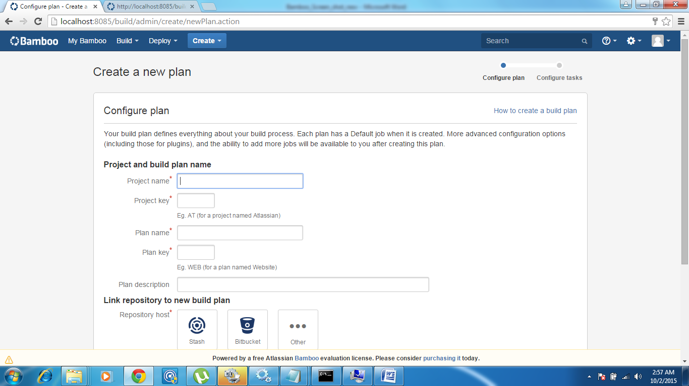

Type Project Name: Zaveta

Plan Name: Zaveta_Release0

Plan Desc: Release0

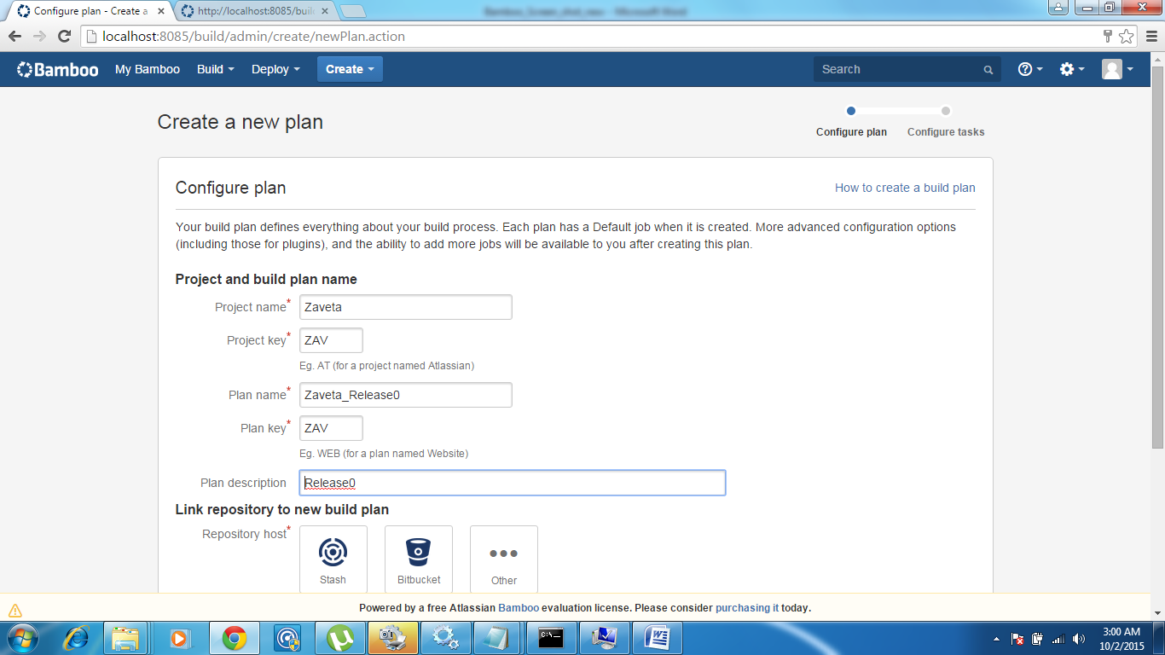

Link repository to new build:

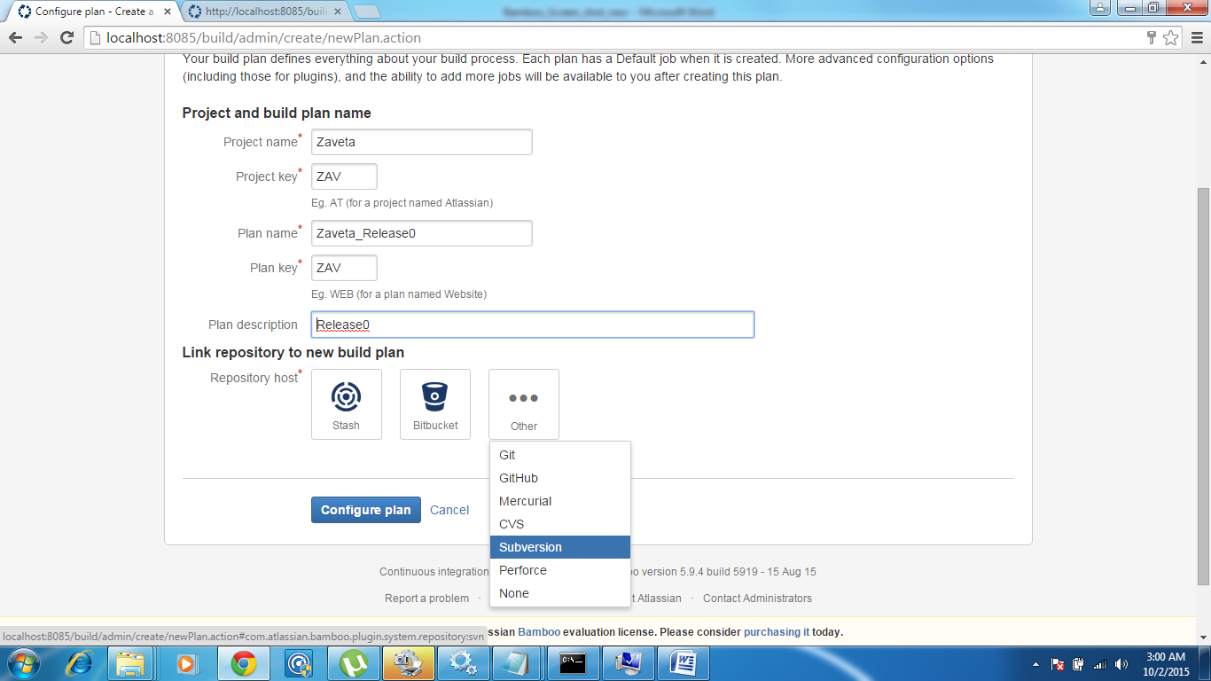

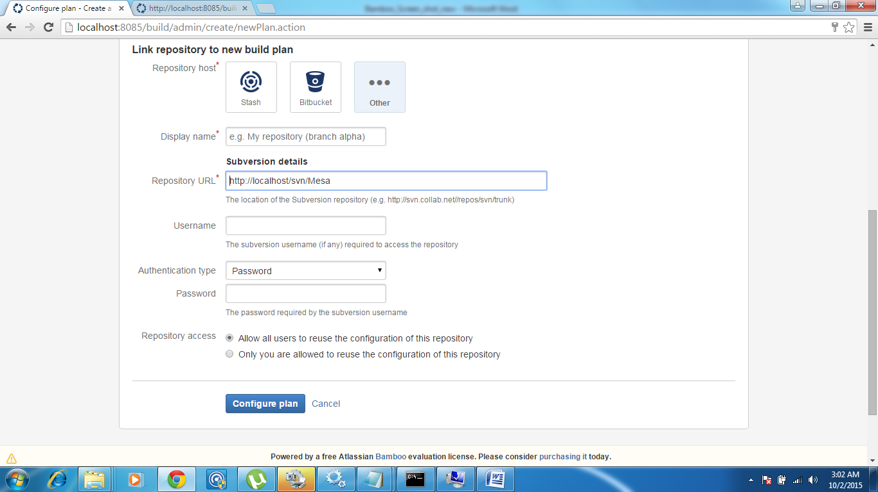

Type SVN repository URL: <http://localhost/svn/Mesa>

Also provide svn repository user name & password

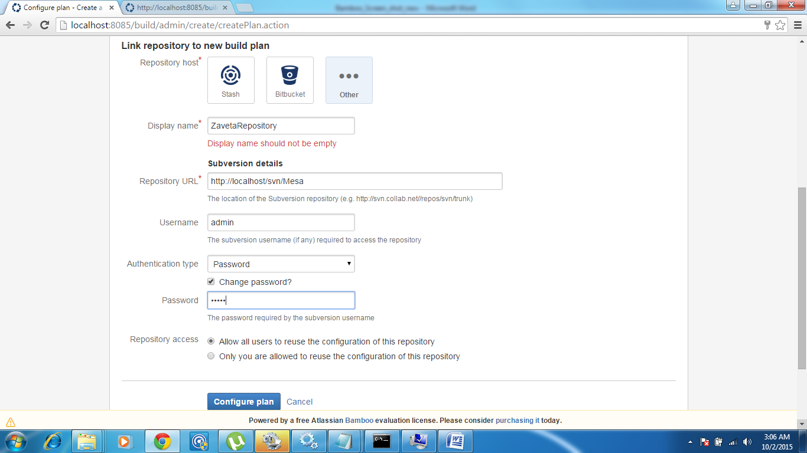

Click on Configure plan

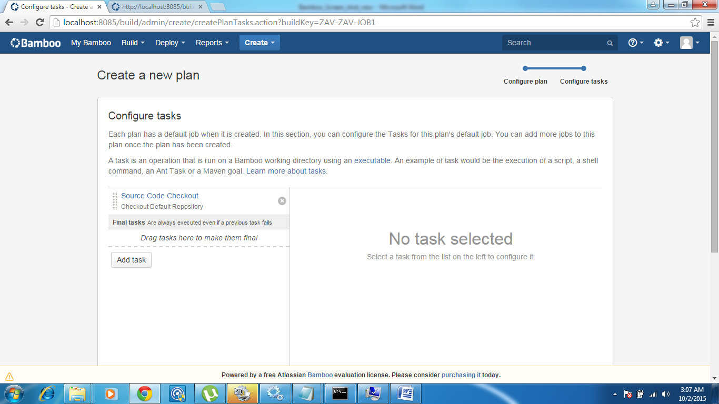

Double Click on Source Code Checkout

Provide Task Description

Repository will come automatically

Mention Checkout Directory name (SourceCode)

Select “Force clean new build”

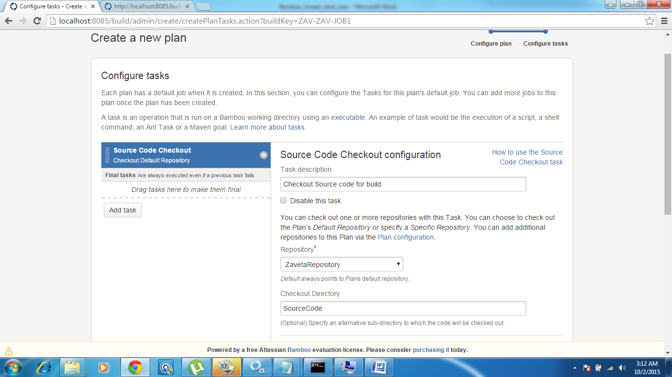

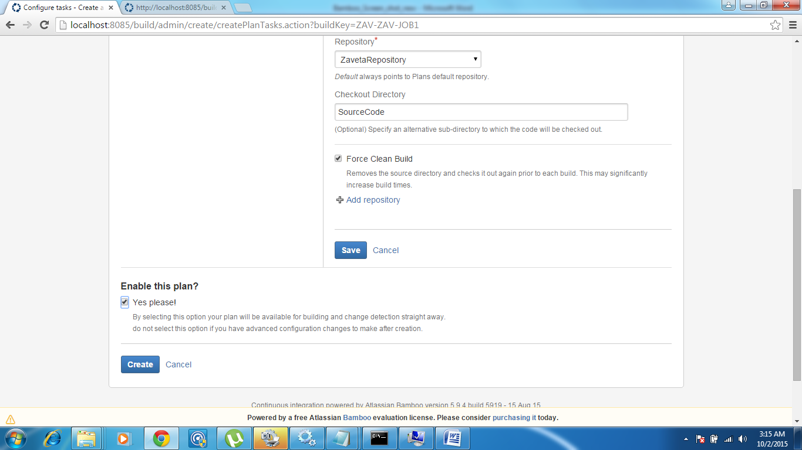

Save & Create

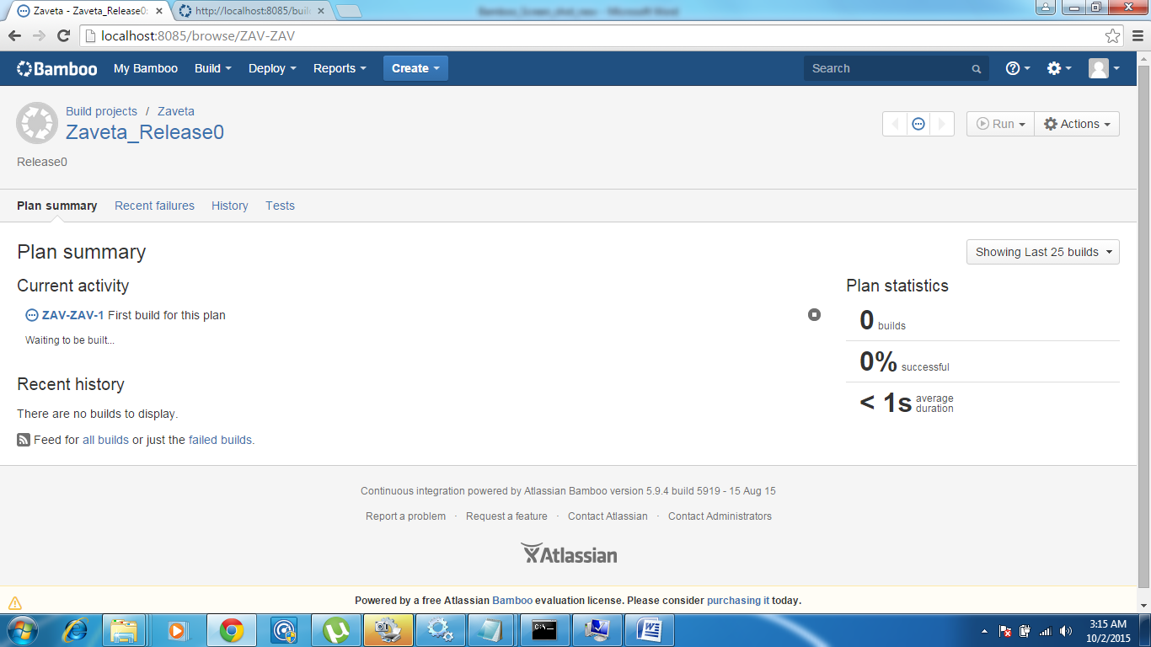

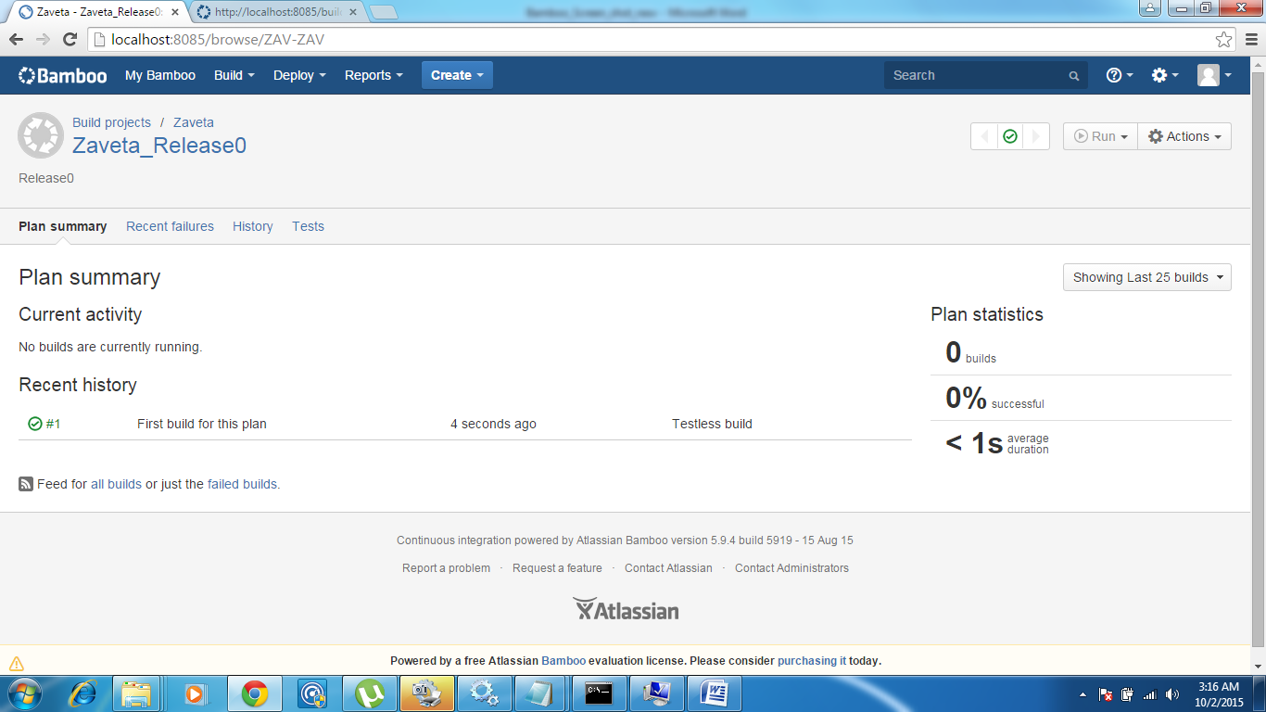

SourceCode will be checkout in below directory

E:\bamboo-user\xml-data\build-dir\ZAV-ZAV-JOB1

This completes Bamboo integration with SVN.

Configuration to trigger build as soon as changes are committed to repository:

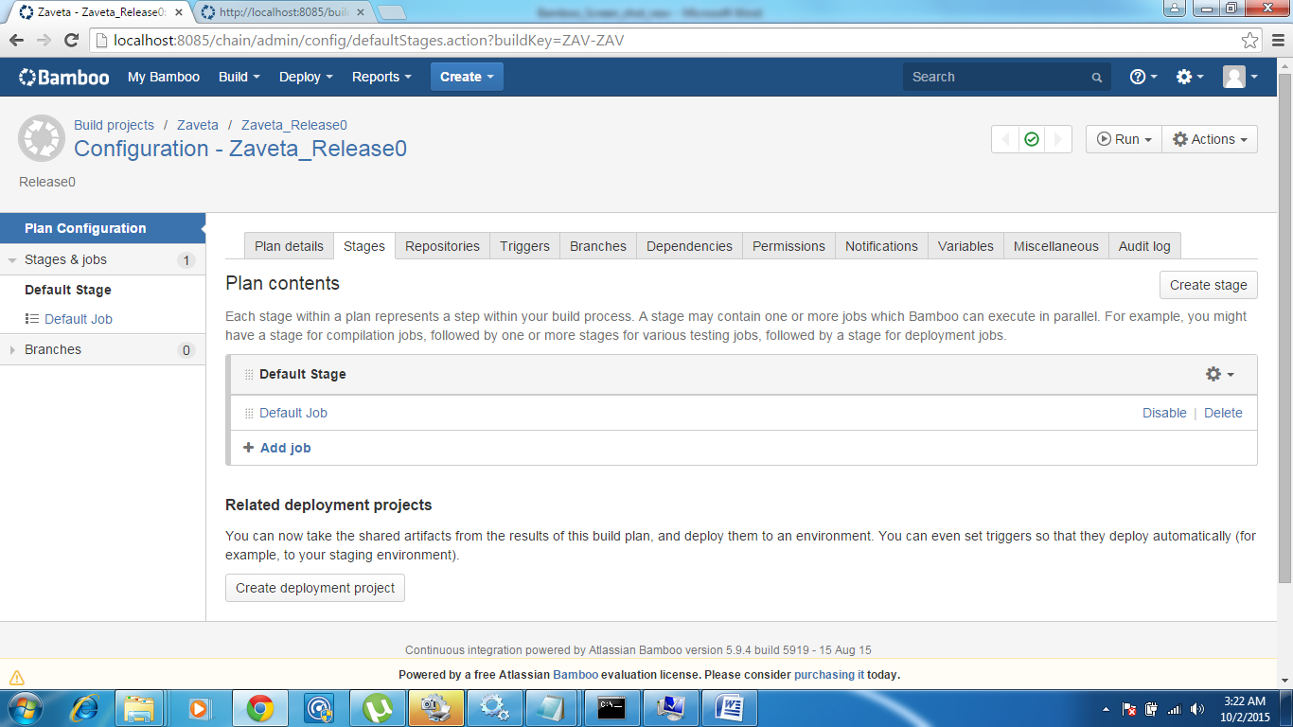

Select Overview:

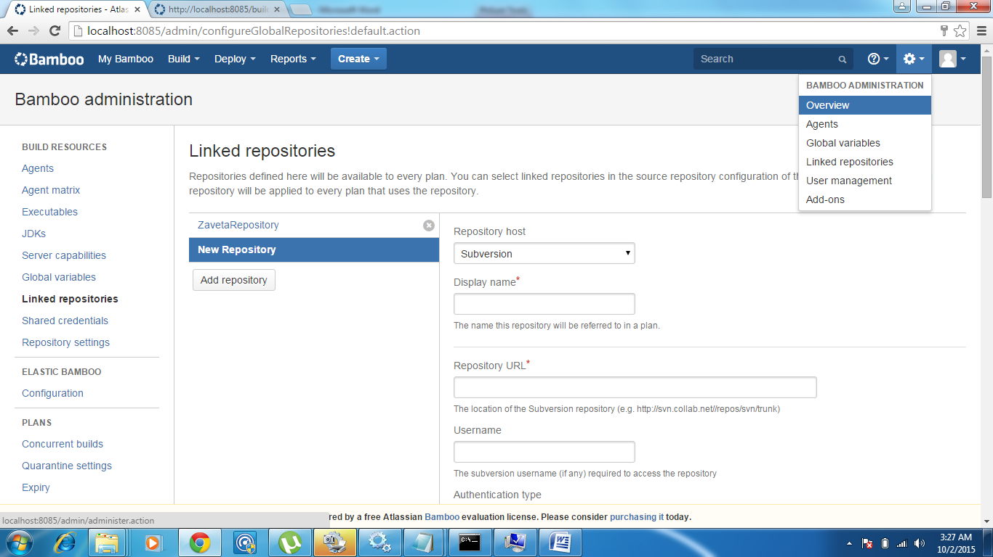

Click on “Linked repositories” & Add repository

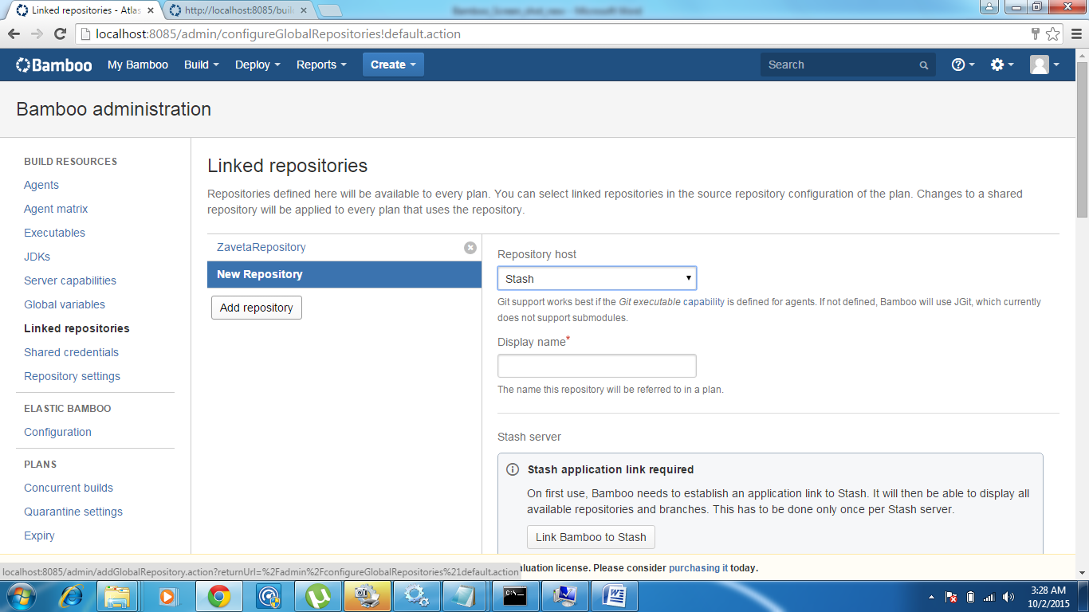

Select SVN

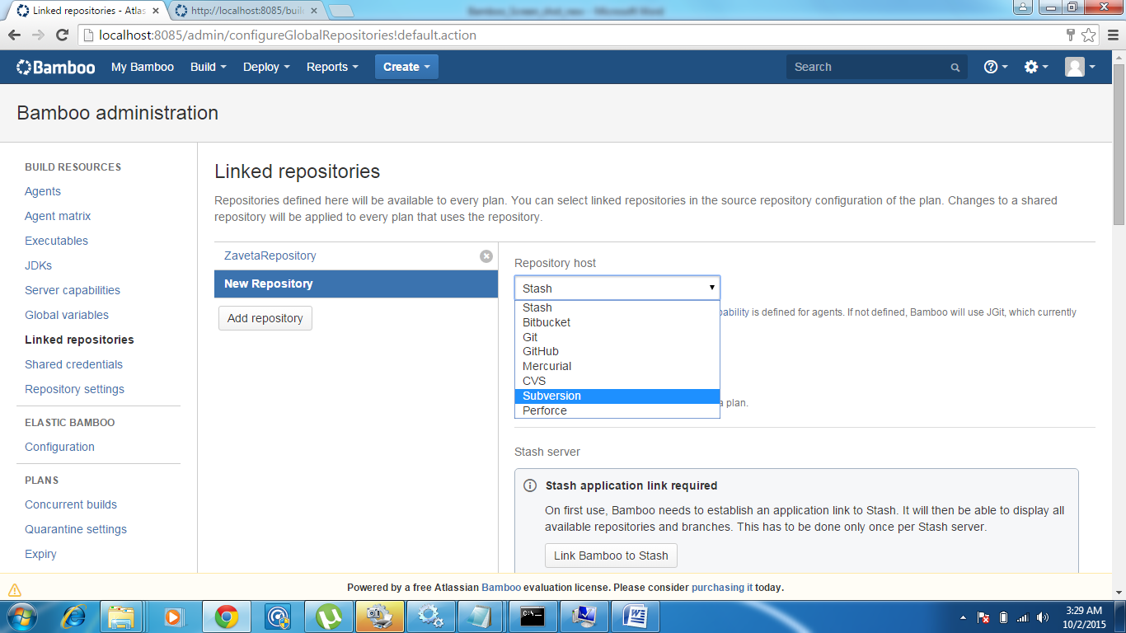

Provide details for Display Name, Repository URL, Username & Password

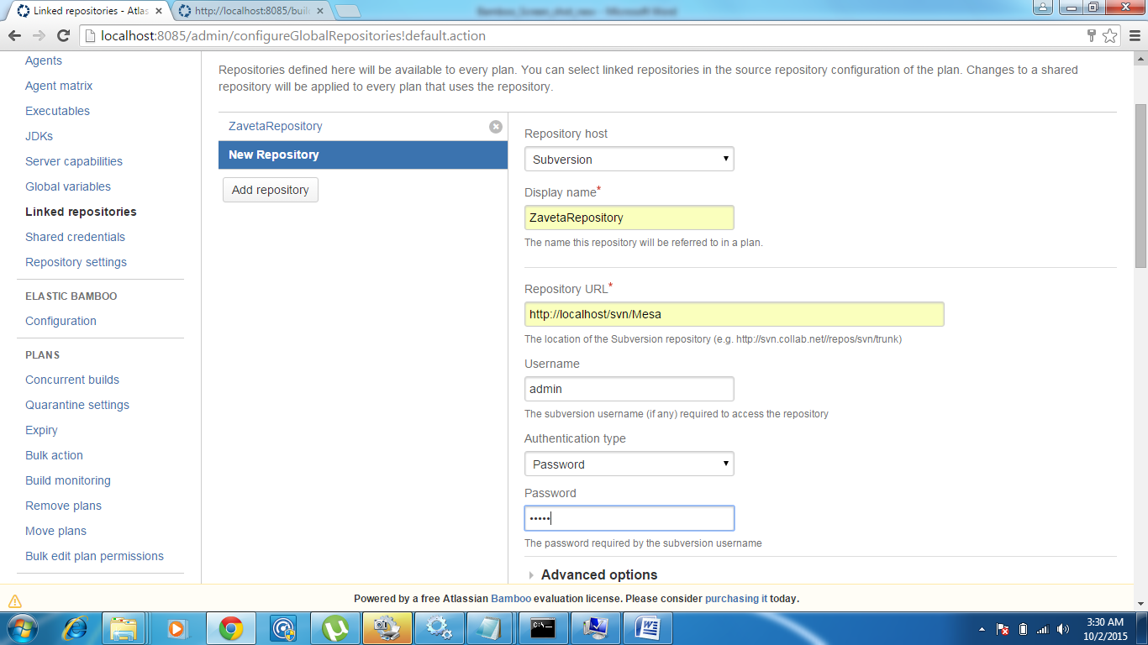

Click on Advanced options

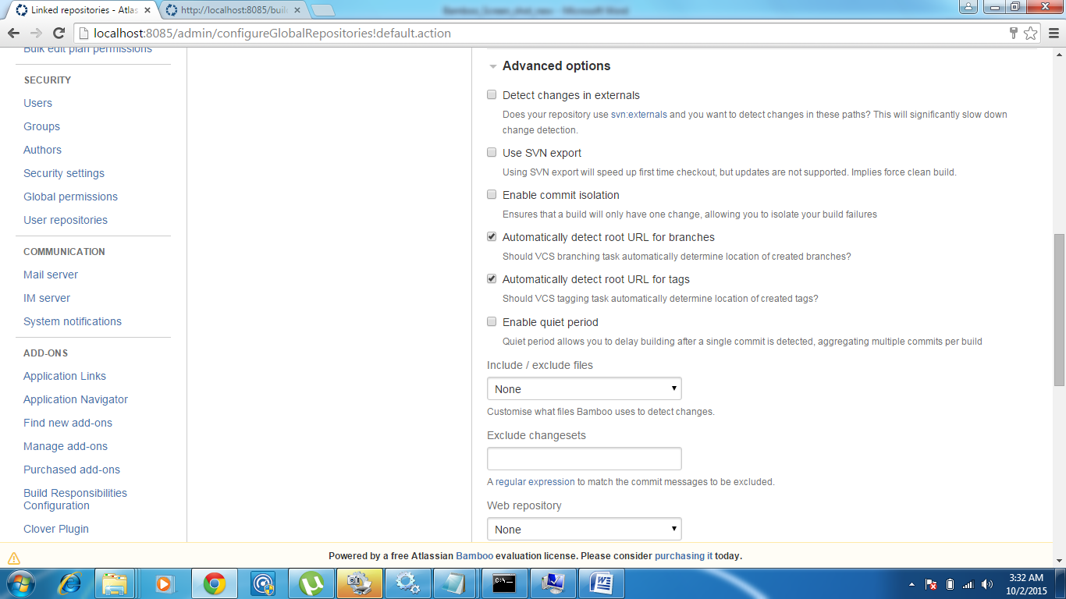

Click on “Enable quir period”

Provide values for Quite period & Maximum retries

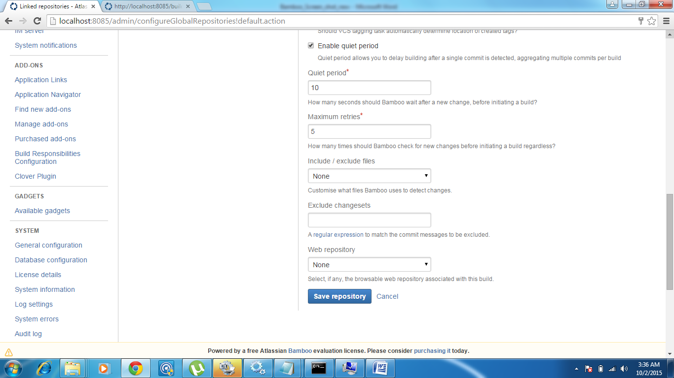

Click on “Save repository”

How to test build after commit

E:\bamboo-user\xml-data\build-dir\ZAV-ZAV-JOB1\SourceCode\trunk\SourceCode\MeSa

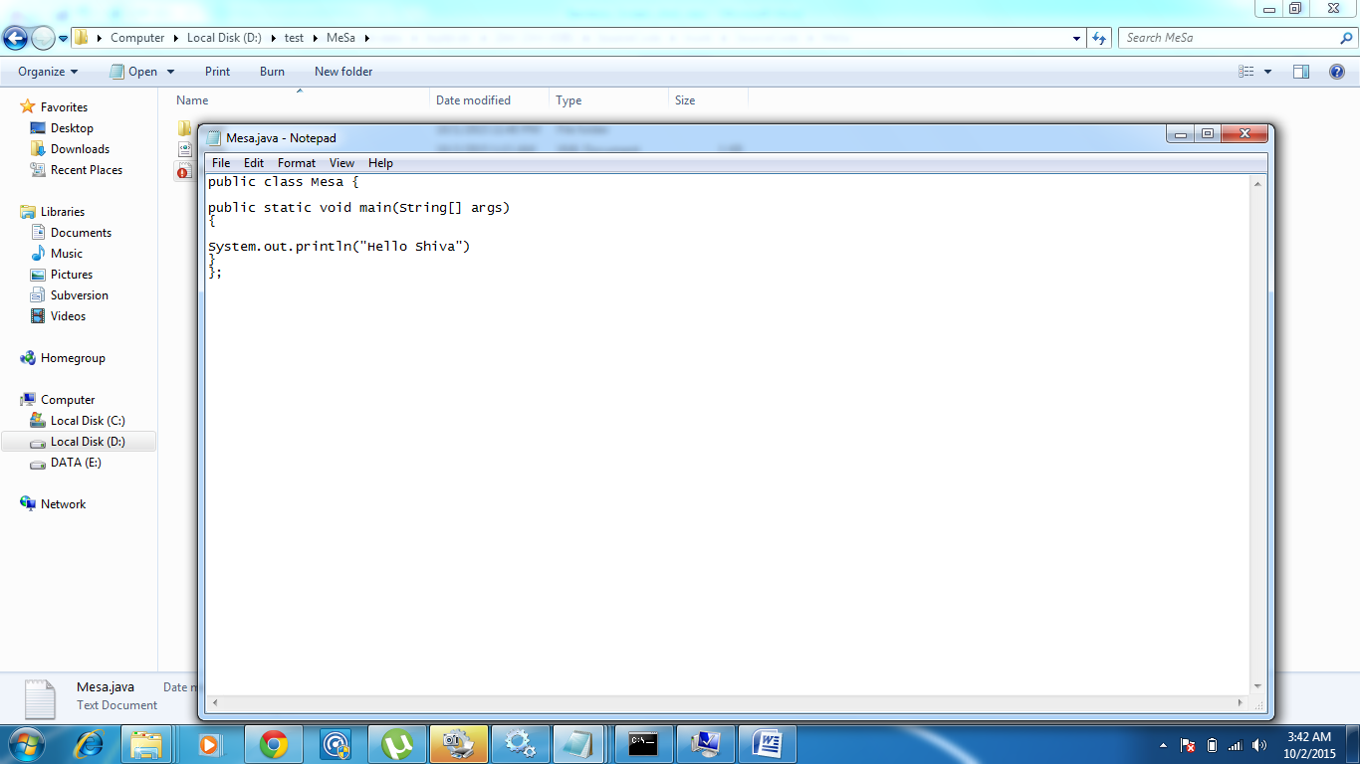

Change code & Save

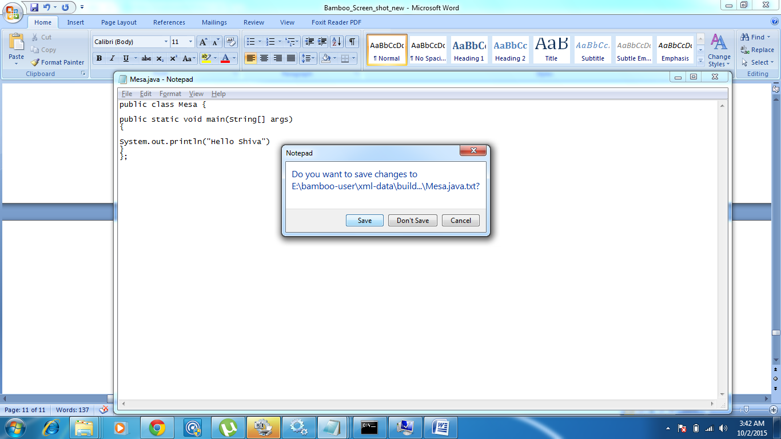

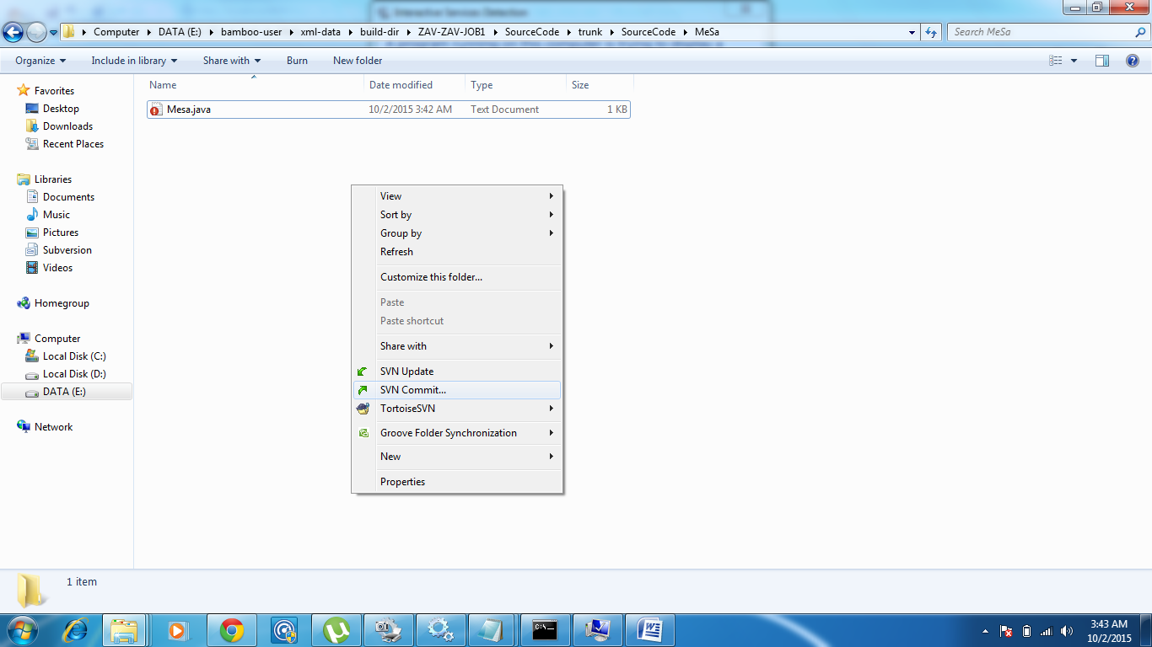

How to integrate ANT (Build tool) with Bamboo

Select All build plans

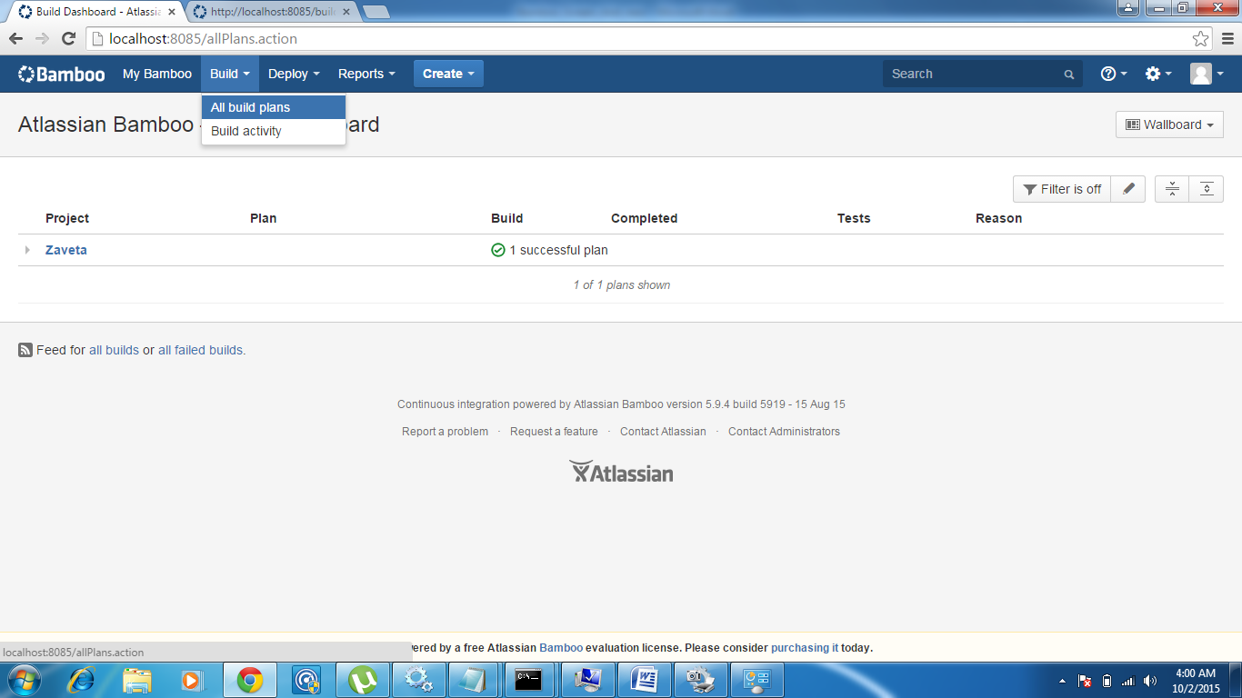

Click on the project and then click on the plan to get the below screen

N t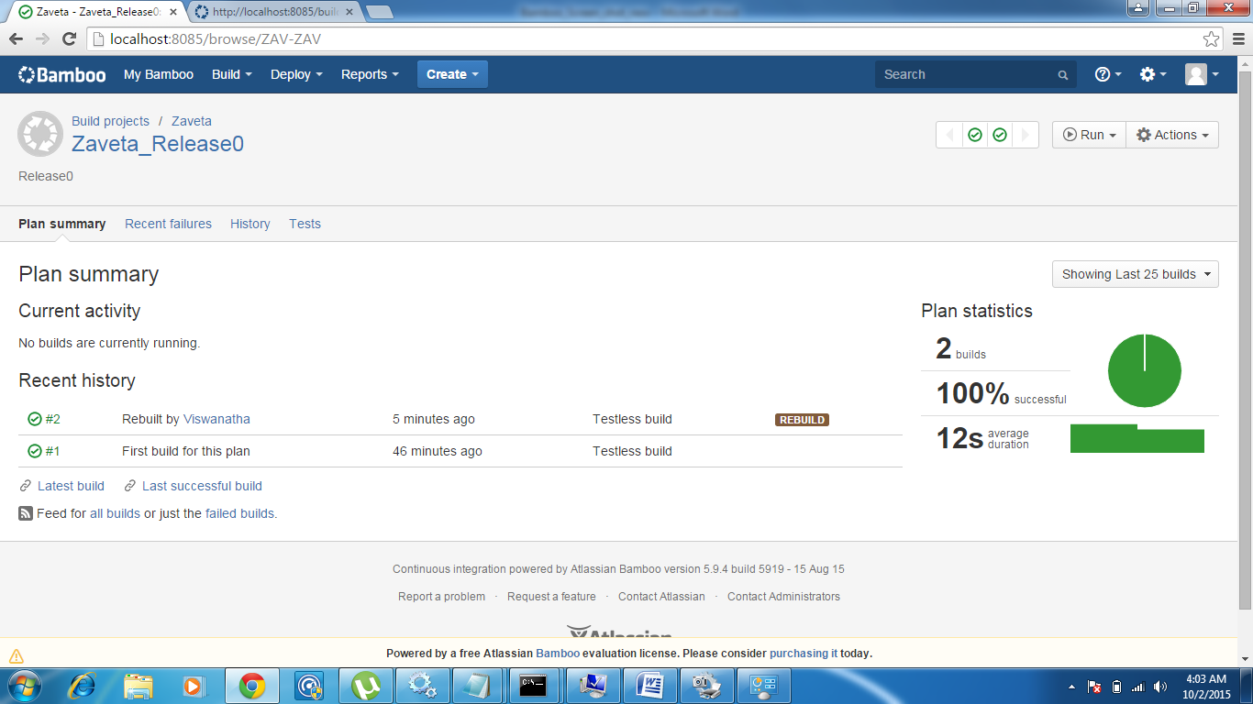

Click on Action menu in the top right corner

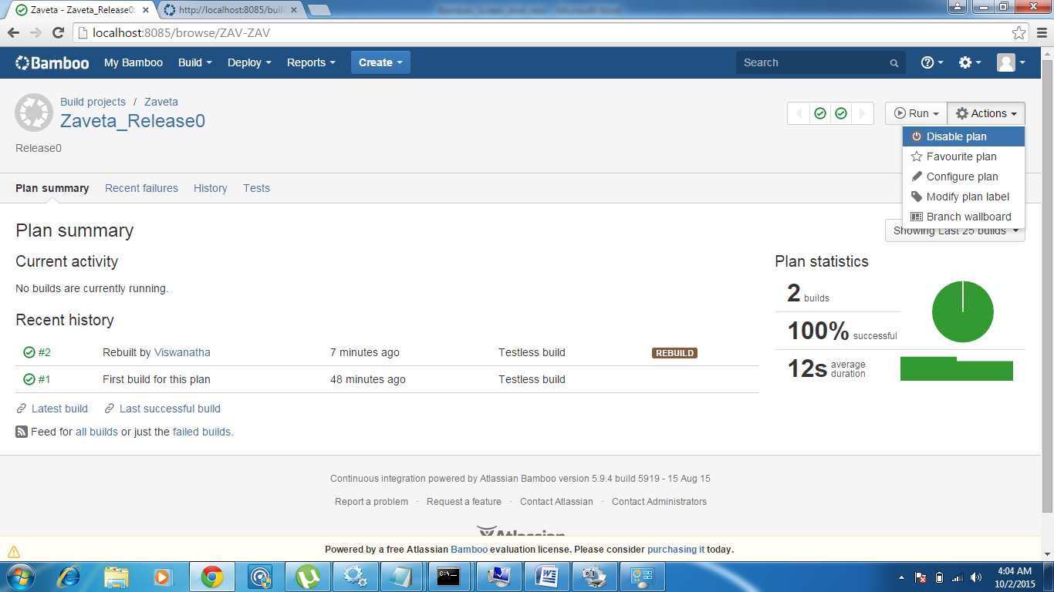

Select configure plan

\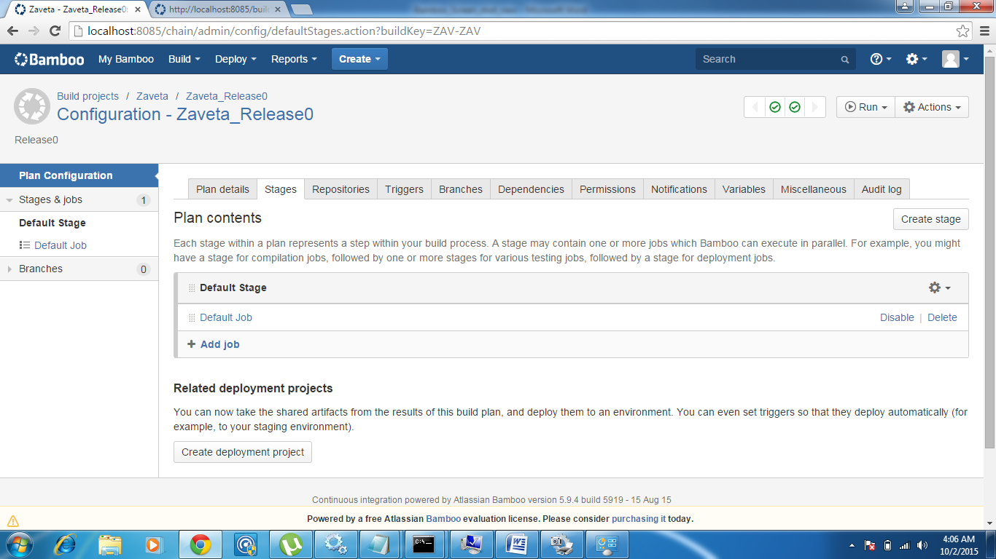

Click on Default Job

& add task

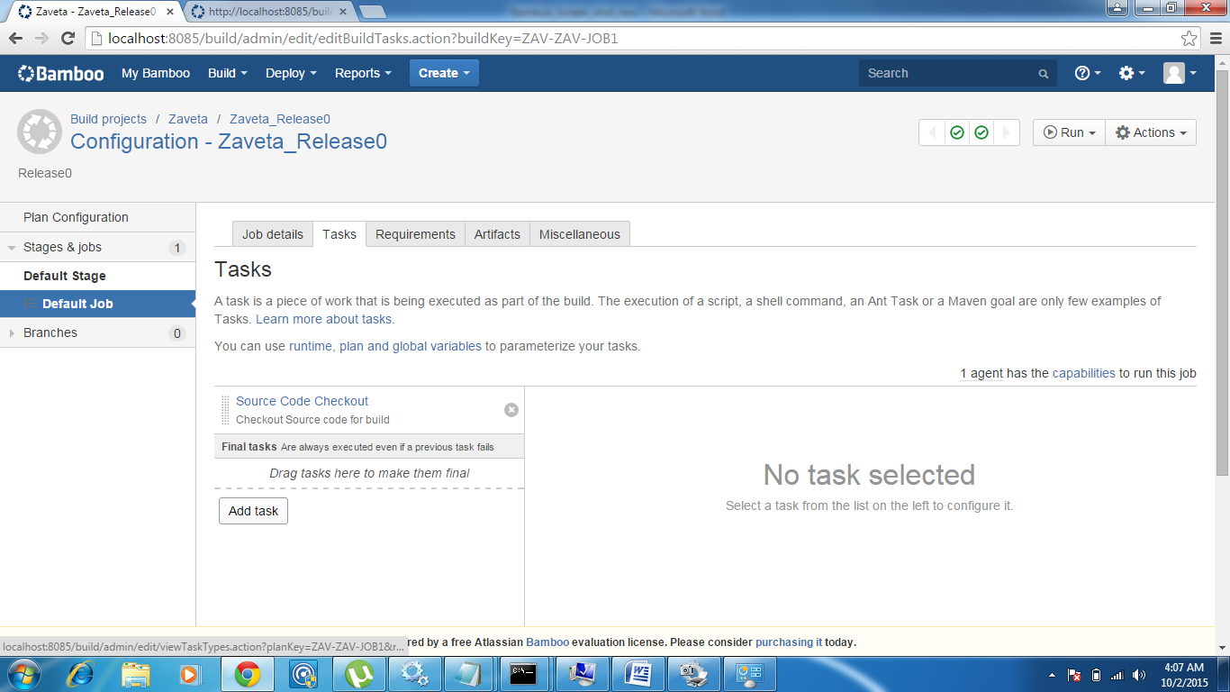

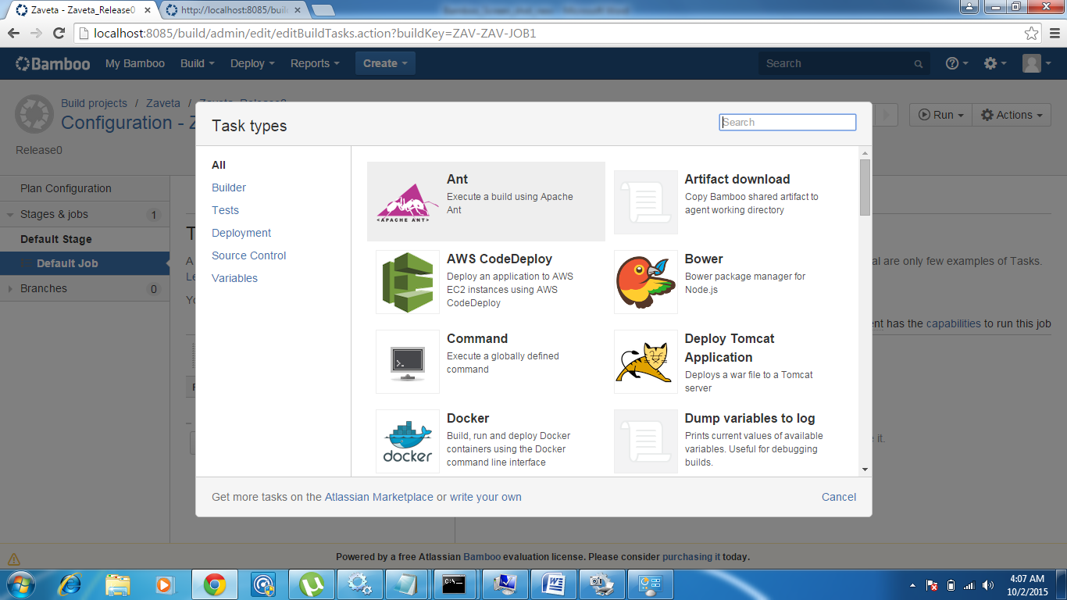

Select Ant

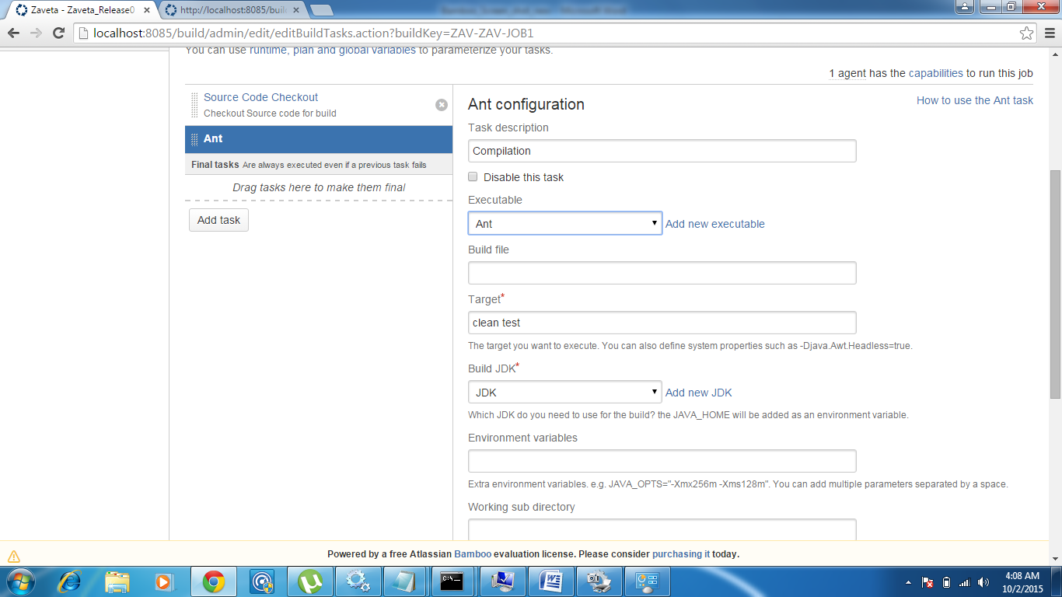

Provide Task description

Pease note, Executable – Ant will automatically come if you have set the ANT_HOME during Bamboo installation:

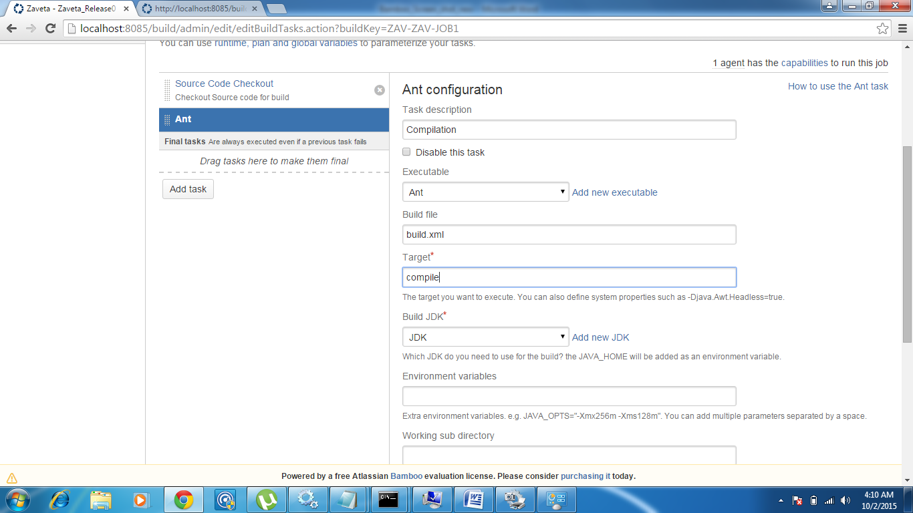

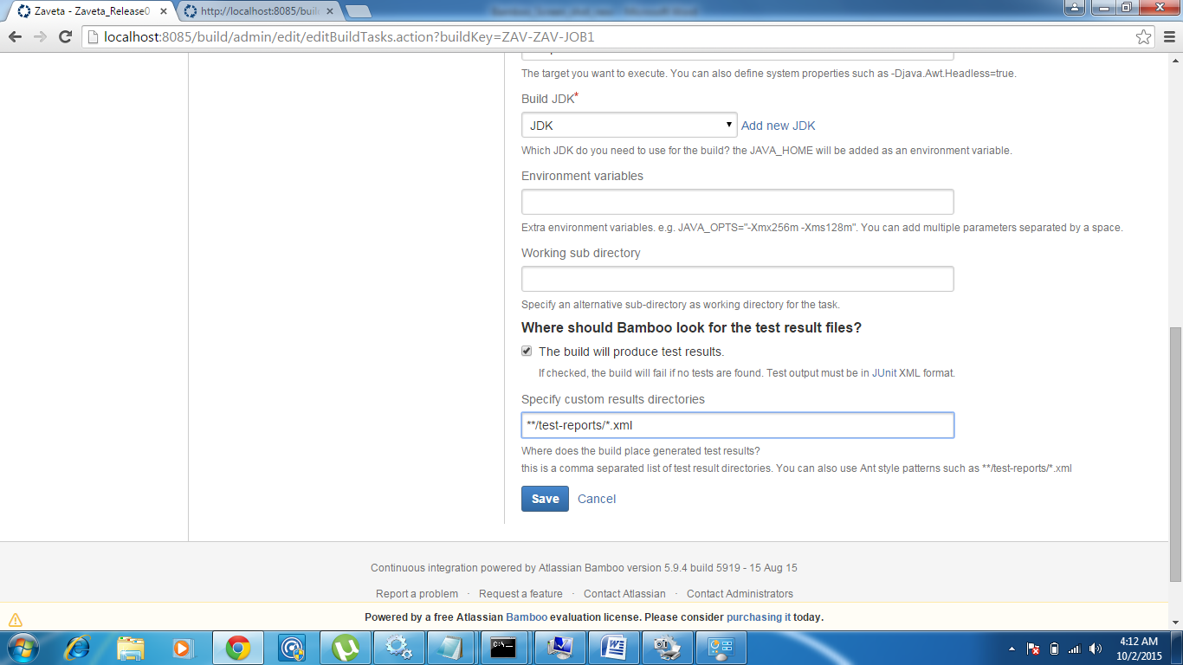

Click on Save

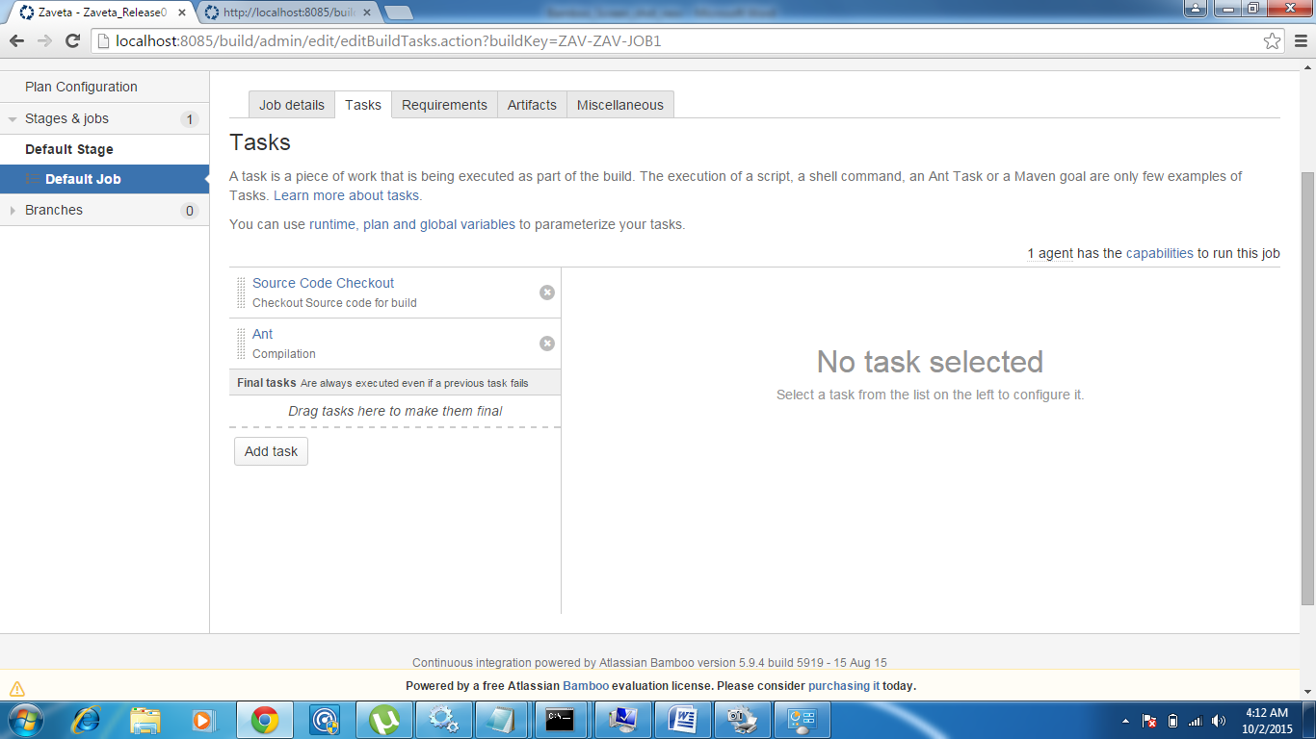

This completed Ant integration:

Click Run Plan to test build.xml

